# CS 255 System Design Document Template

This template lays out all the different sections that you need to complete for Project Two. Each section has guidance to prompt your thinking. You will need to continually reference the interview transcript as you work to make sure that you are addressing your client’s needs. There is no required length for the final document. Instead, the goal is to complete each section based on what your client’s needs are. Remove this note when you are finished and replace all bracketed text with the relevant information.

## UML Diagrams

### UML Use Case Diagram

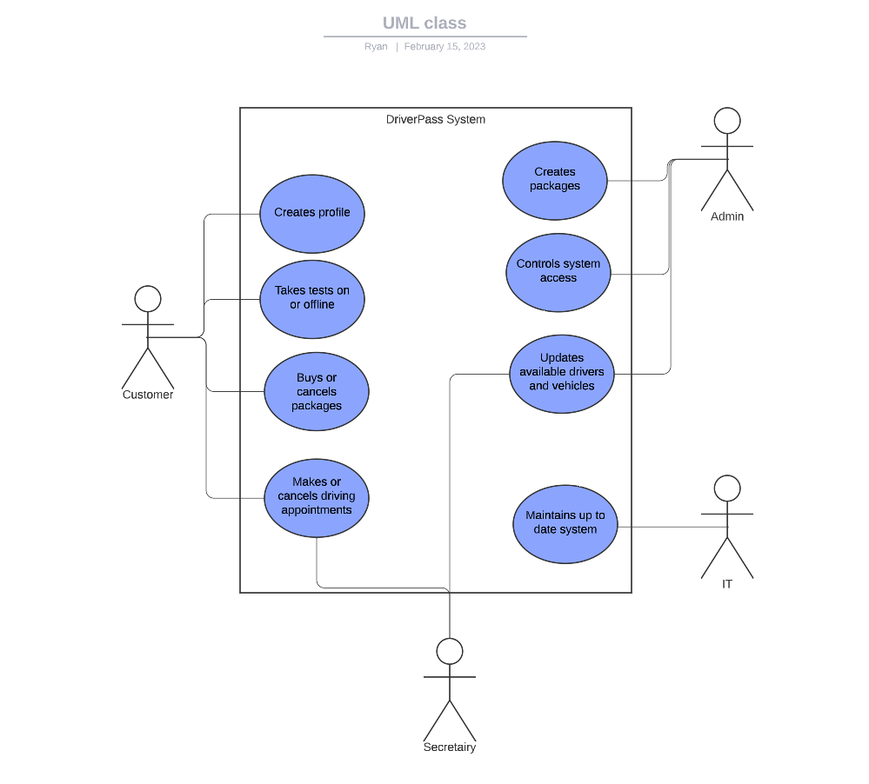

### UML Activity Diagrams

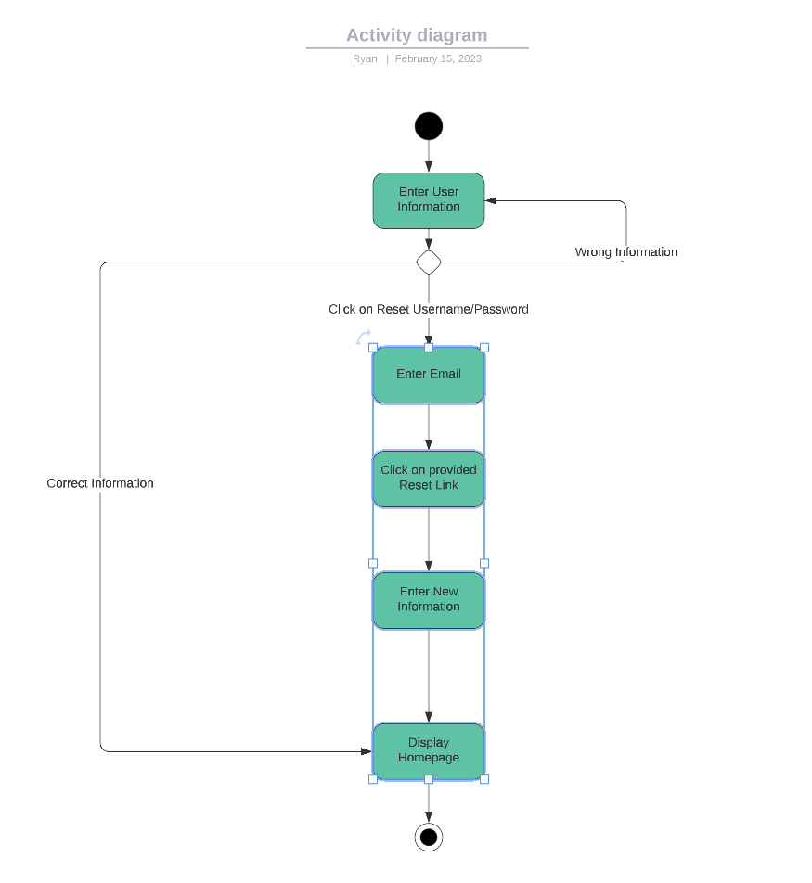

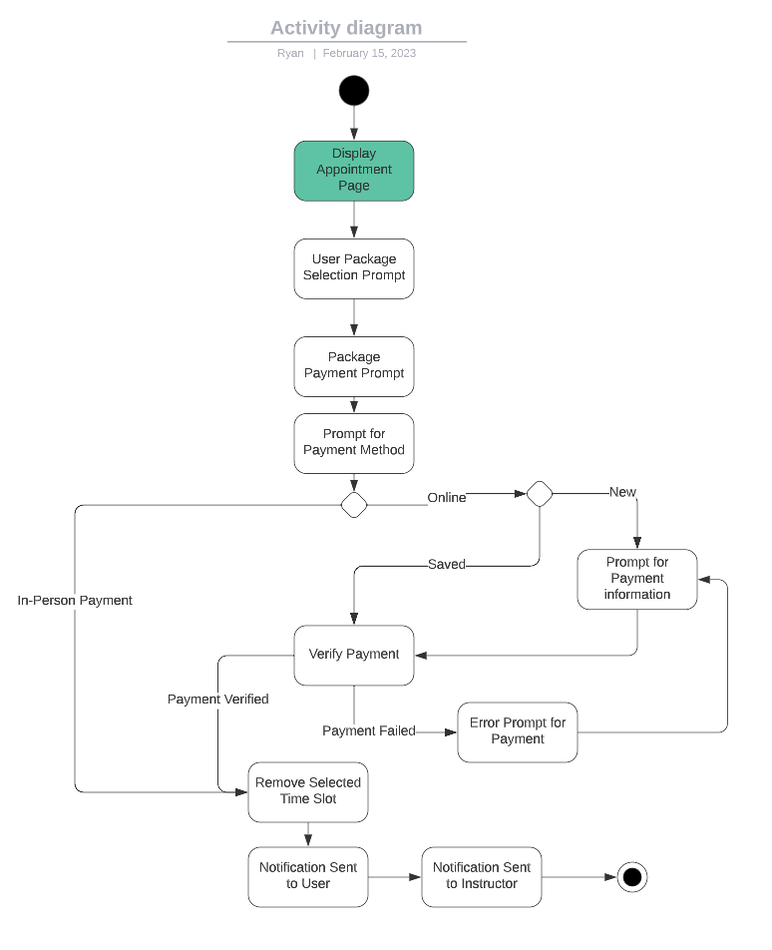

### UML Sequence Diagram

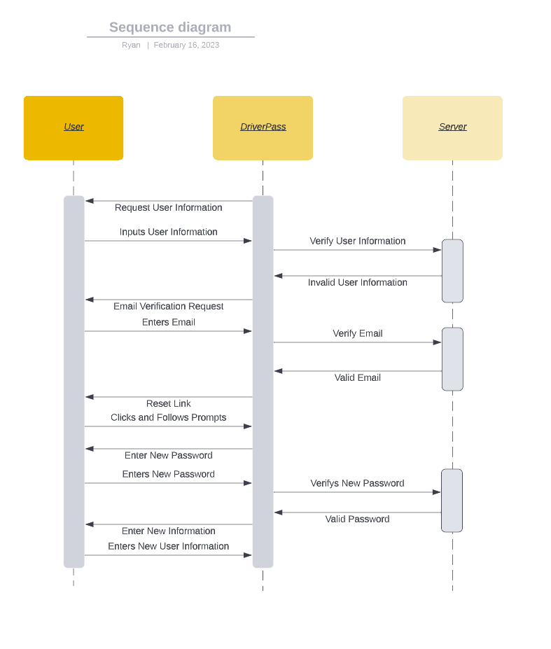

### UML Class Diagram

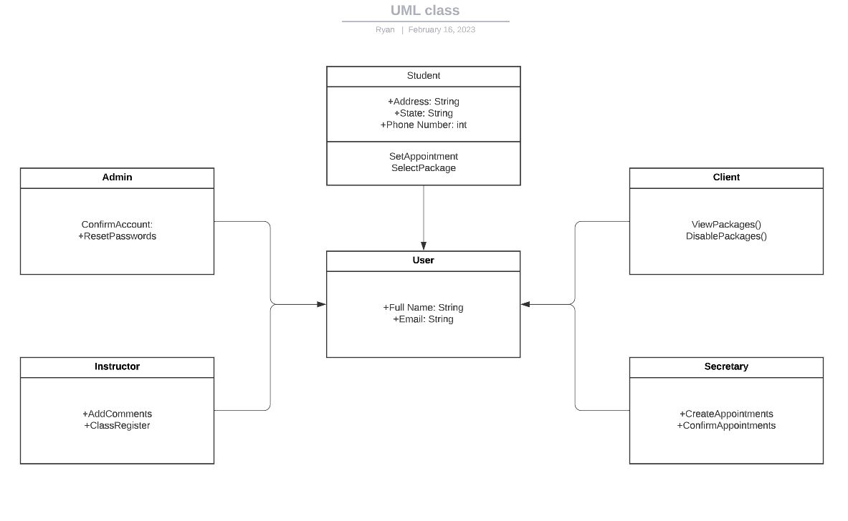

## Technical Requirements

The system will have a few technical requirements. The system will run off a cloud to ensure security. By running off a cloud-based server, information being transferred between the system and the user will have protection. We will also create a mobile version of the system for users to access information anywhere needed. A stable internet connection will also be required to create, run, and maintain the system.